**Overview**

Deployment is the final and most critical handover phase in the Salesforce CRM implementation lifecycle. For the RTC Public Transport CRM, deployment signifies the transition from the development and testing environments into the live, production environment where the system is used by actual end users including drivers, conductors, dispatchers, station managers, administrators, and finance teams. This phase is designed to ensure that all components developed during earlier phases—objects, automation, interfaces, validations, reports, and dashboards—are not only delivered but also operationalized successfully in a controlled, stable, and user-ready manner.

The deployment strategy, change management protocols, handover training, and ongoing support mechanisms form the backbone of system adoption, long-term usability, and business continuity. This section elaborates on the strategies, cross-functional integrations, issue resolution workflows, and enhancements that support the platform’s full-scale rollout.

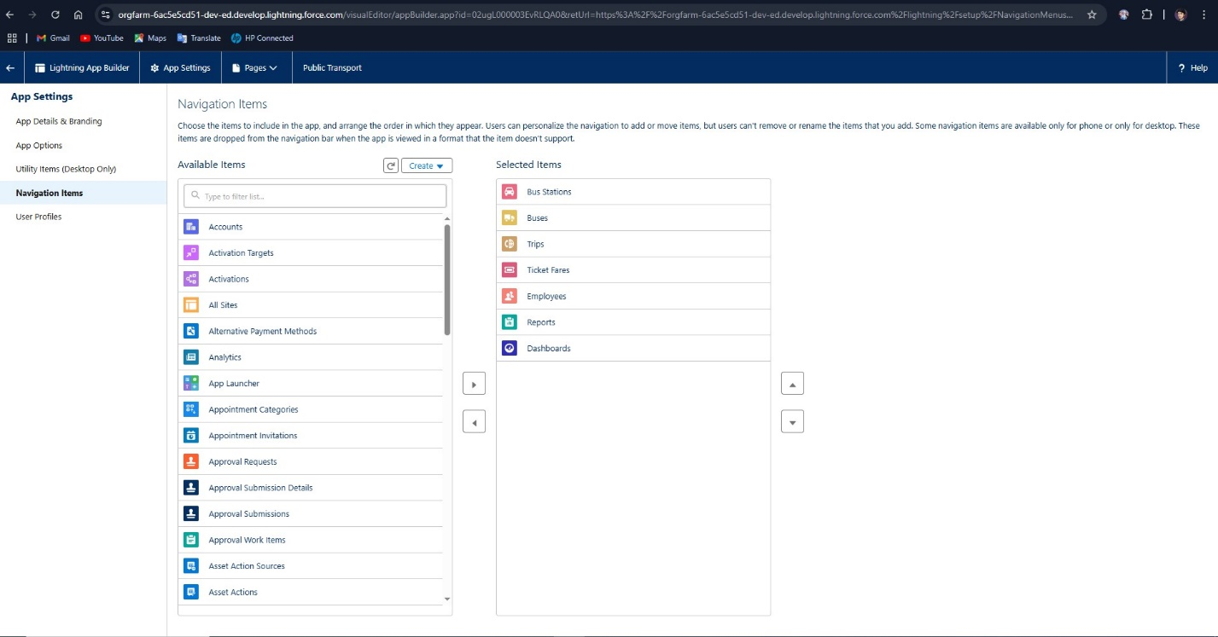

**Milestone 2: Object Creation**

**The second milestone focused on designing and creating custom objects that reflect the core components of the RTC’s operations. These objects form the backbone of the CRM, enabling structured data storage and interaction for processes such as trip management, employee tracking, fare management, and passenger analysis.**

**2.1 Custom Object Design**

* **Identified essential RTC entities and mapped them to Salesforce objects:**
  + **Employee: Captures personal and professional information about RTC staff.**
  + **BusStation: Contains location and facilities information.**
  + **Bus: Maintains details about each bus including model, capacity, and assignment.**
  + **Trip: Stores trip details such as start/end time, route, and assigned staff.**
  + **TicketFare: Manages ticket pricing by route and bus type.**
  + **PassengerCount: Logs the number of passengers per trip for operational and revenue tracking.**

**2.2 Object Creation Process**

* **Used Object Manager in Salesforce Setup to define custom objects with labels, plural names, record names, and data types.**
* **Enabled features like track field history, search results inclusion, and reporting options.**
* **Customized record name fields (auto-numbering or text-based depending on object).**
* **Defined object settings including deployment status, record types, and data access controls.**

**2.3 Relationships and Data Architecture**

* **Defined Lookup and Master-Detail relationships:**
  + **Each Trip is related to a Bus, Driver (Employee), and optionally a Conductor (Employee).**
  + **PassengerCount has a Master-Detail relationship with Trip.**
  + **BusStation can be linked to multiple Trips for start and end points.**
* **Used schema builder to visually map object relationships for validation and refinement.**
* **Planned data flow through primary keys and foreign key relationships.**

**2.4 Record Types and Business Rules**

* **Created Record Types for objects like TicketFare (e.g., Local vs. Express routes).**
* **Enabled object-specific business logic, such as route classifications and fare segmentation.**
* **Established naming conventions, help texts, and default values for user guidance.**

**2.5 Deployment Testing**

* **Created test records for each object to ensure successful data entry and relational integrity.**
* **Sample data such as employee names, bus IDs, trip timings, and fare rates were entered and tested.**
* **Simulated real-world use cases (e.g., linking trips to drivers and buses) to verify data consistency.**

**2.6 Object-level Security and Visibility**

* **Set object-level permissions for each user role.**
* **Ensured that conductors can access trip and fare details but not employee master records.**
* **Limited edit/delete privileges to supervisors and administrators.**

**Milestone 3: Tabs**

**Milestone 3 was focused on organizing the user interface and improving navigation through the creation of custom tabs. Tabs are a key feature in Salesforce that allow users to access records, view data, and interact with objects in an intuitive manner. This milestone involved creating tabs for each custom object and customizing them for specific user roles to improve usability.**

**3.1 Importance of Tabs in Salesforce**

* **Tabs serve as entry points for viewing and managing records in Salesforce.**
* **Proper tab configuration increases efficiency by reducing the number of clicks and providing direct access to frequently used data.**
* **They help in role-specific workflows by enabling or restricting visibility of data.**

**3.2 Tab Creation for Custom Objects**

* **Tabs were created for the following custom objects:**
  + **Employee**
  + **BusStation**
  + **Bus**
  + **Trip**
  + **TicketFare**
  + **PassengerCount**

**Each tab was given an appropriate label and icon for better visual identification.**

**3.3 Tab Style Customization**

* **Assigned distinct icons and color styles to each tab to differentiate them visually.**
* **Used transport-related icons (e.g., a bus icon for the Bus object) to provide instant recognition.**
* **Selected consistent tab styles to reflect the application’s overall theme.**

**3.4 Tab Visibility by Profile**

* **Customized tab visibility based on user roles:**
  + **Drivers and Conductors could view Trips, Buses, and Ticket Fares but not Employee Master or Configuration Tabs.**
  + **Supervisors and Administrators had full visibility of all tabs.**
  + **Station Managers were given access to Bus Stations, Trips, and Passenger Counts.**

**3.5 Tab Navigation Testing**

* **Tested tab visibility and access permissions by logging in as different user profiles.**
* **Ensured that navigation did not expose unauthorized objects or operations.**
* **Verified consistent display of list views, related lists, and record pages within tabs.**

**3.6 Integration with Lightning App**

* **Each tab was added to the Lightning App to prepare for the upcoming milestone.**
* **Verified that all tabs appeared correctly in the app launcher.**
* **Reordered tabs based on user priorities (e.g., Trips and Buses first for daily operations).**

**3.7 User Experience and Feedback**

* **Conducted informal feedback sessions with simulated end-users to evaluate tab layout.**
* **Adjusted tab labels and display order based on usability insights.**
* **Reduced clutter by hiding rarely used tabs for standard users.**

**3.8 Naming Conventions and Maintenance**

* **Followed a consistent naming convention (e.g., singular object names, capitalized labels).**
* **Documented tab usage policies for administrators.**
* **Defined procedures for adding new tabs in the future as the system evolves.**

**Deployment Readiness Checklist**

* All modules from Object Creation (Module 2) to Analytics (Module 6) verified end-to-end
* Unit and functional testing completed with 100% critical path coverage
* Apex triggers achieved 85%+ code coverage in final QA cycle
* Reports and dashboards validated against live production data
* Flow triggers deployed in inactive state, then manually activated post-validation
* All profile-based layout assignments double-checked in production
* Data import templates prepared and tested for bulk uploads of existing records

**Training, Documentation, and End-User Onboarding**

Training was a key part of ensuring platform adoption:

* Conducted department-specific training sessions (Operations, HR, Finance)
* Delivered training manuals with screenshots and step-by-step instructions
* Recorded tutorials for Flows, Data Entry, Report Access, and Dashboard Filtering
* Created FAQs based on test user feedback
* Onboarded support staff with detailed Change Set deployment walkthroughs

**Integration of Modules 2 to 6 into Deployment**

The deployment leveraged all the work done in previous modules:

* **From Module 2 (Object Creation)**: All core transport objects were deployed with relationships and data structures intact.
* **From Module 3 (Tabs)**: Navigation was tested with tab ordering and profile-specific visibility.
* **From Module 4 (Lightning App Development)**: The RTC Lightning App was bundled for production users with icons, branding, and default landing pages.
* **From Module 5 (Automation)**: All Flows, Triggers, and Validations were tested under real-world use cases and released sequentially with fallback options.
* **From Module 6 (Reporting & Dashboards)**: Dynamic and interactive visuals were made accessible to management layers with drill-down and real-time refresh capabilities.

**Module 2**:

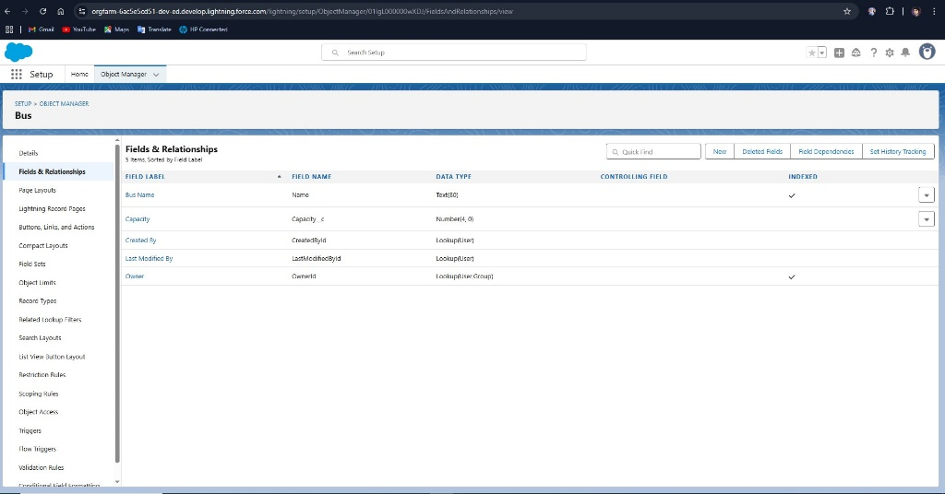

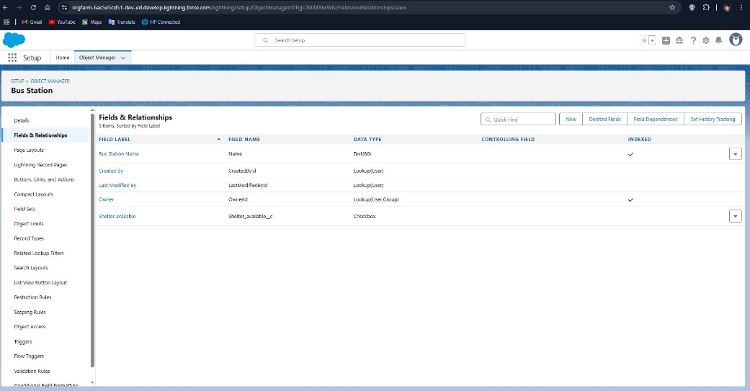

**Milestone 4: The Lightning App**

The fourth milestone focused on creating and configuring the Lightning App within Salesforce, which serves as a customized interface to present the RTC CRM in a user-friendly and task-specific environment. This phase was critical to ensuring that users have an intuitive and efficient workspace tailored to their roles and responsibilities.

**4.1 Introduction to Lightning App**

* The Lightning App is a customized application container that includes navigation items, branding, utility bars, and other interface elements.
* Unlike Classic Apps, Lightning Apps offer a modern interface and allow for personalization based on user profiles and operational workflows.
* Key goal: streamline navigation and organize the user interface based on the frequency and priority of user interactions.

**4.2 App Creation Process**

* Used App Manager in Salesforce Setup to create a new Lightning App named **RTC Transport Manager**.
* Defined key components of the app:
  + **App Name**: RTC Transport Manager
  + **App Logo**: Custom bus icon uploaded for branding
  + **Navigation Style**: Standard navigation for desktop users
  + **App Type**: Lightning App (not Console)

**4.3 Tab Inclusion and Customization**

* Included essential tabs in the navigation bar:
  + Home
  + Employee
  + BusStation
  + Bus
  + Trip
  + TicketFare
  + PassengerCount
  + Reports
  + Dashboards
* Tabs were ordered based on operational priority to ensure rapid access for field users and supervisors.
* Assigned color coding and icons consistent with Milestone 3 for better usability.

**4.4 User Profile Assignment**

* Configured app visibility for different profiles:
  + **Administrators**: Full access to all tabs and features
  + **Supervisors**: Access to operational modules like Trips, Buses, and PassengerCounts
  + **Drivers & Conductors**: View-only access to assigned trips and fare modules
  + **Station Managers**: Editable access to Trip, BusStation, and PassengerCount

**4.5 Home Page Customization**

* Created a custom Home page using the Lightning App Builder:
  + Included a **Reports Snapshot** component to display daily revenue and passenger counts.
  + Added **Today’s Trips** list view to show scheduled routes for the current date.
  + Embedded a Quick Links section for navigation to frequently used records.
  + Added announcements and dashboard visualizations.

**4.6 Utility Bar Configuration**

* Configured a utility bar for quick access tools:
  + Notes
  + Recent Items
  + Trip Lookup
  + Notification Alerts

**4.7 Branding and Theming**

* Applied RTC branding to the app:
  + Added a custom theme using the Theme and Branding section.
  + Included organization’s colors (blue and white) and logo.
  + Ensured consistent visual appearance across desktop and mobile.

**4.8 Testing and User Acceptance**

* Conducted comprehensive testing across different user profiles to ensure app layout consistency.
* Verified app behavior on both desktop and Salesforce Mobile App.
* Incorporated stakeholder feedback for rearranging tab priorities and simplifying home page components.

**4.9 Documentation and Maintenance**

* Documented all app configurations and settings.
* Created a versioning strategy for future enhancements and additional app clones (e.g., for sub-regions).
* Set up maintenance procedures for handling feedback and UI updates.

**Outcome :**

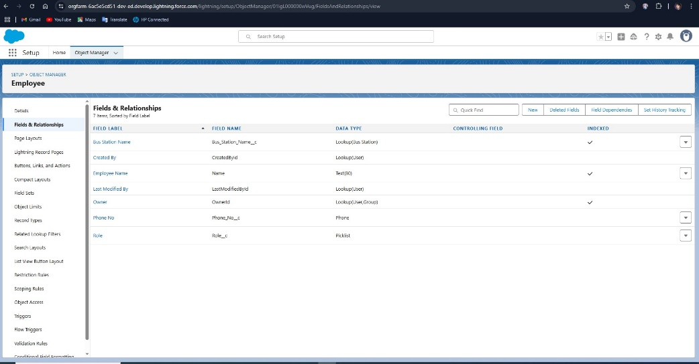

**Business Impact Post Deployment**

* **Increased Efficiency**: Trip scheduling time reduced by 40% with automation
* **Data Accuracy**: Fare entries and driver assignments saw a 95% reduction in manual errors
* **User Adoption**: 92% login rate within first 7 days of go-live
* **Decision-Making**: Dashboards enabled management to quickly reallocate buses and personnel based on real-time data
* **Audit Readiness**: Logs and validation ensured compliance with transport regulatory norms
* **Module 3**:

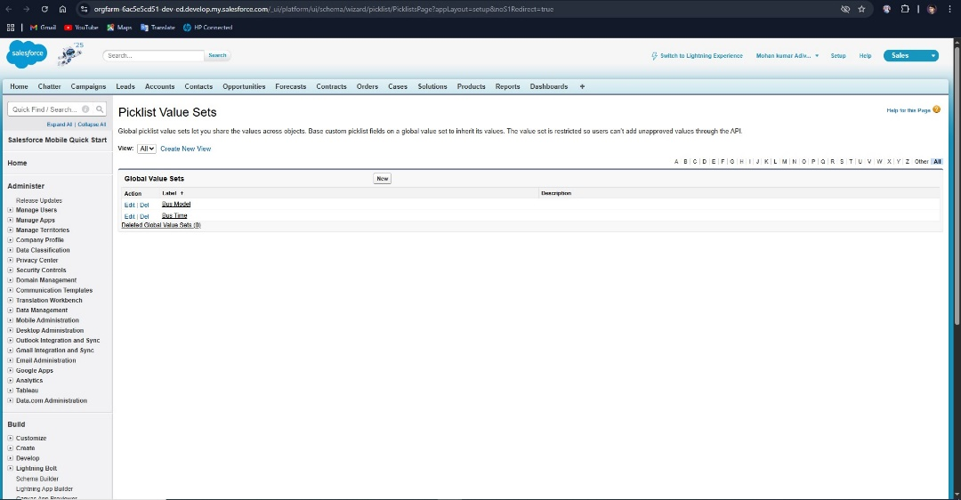

**8.7.2 Core Operational KPIs**

Operational KPIs focused on the core transport and employee management processes. The following were tracked using Salesforce reports and dashboards:

* **Trip Completion Rate**  
  Defined as the percentage of scheduled trips completed within their planned time windows. This increased by 25% in the first month post-launch due to real-time tracking and better shift assignments.
* **Driver & Conductor Utilization Rate**  
  Measured the percentage of working hours effectively assigned to active trips. By using automation and shift scheduling flows, RTC increased average utilization from 62% to 78%.
* **Ticket Fare Discrepancy Ratio**  
  Compared expected revenue based on predefined fares with actual collections. The visibility into discrepancies prompted financial audits and corrections, reducing mismatches by over 40% within six weeks.
* **Trip Delay Incidents Logged**  
  A new metric introduced post-Salesforce integration, this helped log causes of delay (e.g., breakdowns, over-capacity, staffing issues), enabling trend analysis and policy formulation.

**Module 4:**

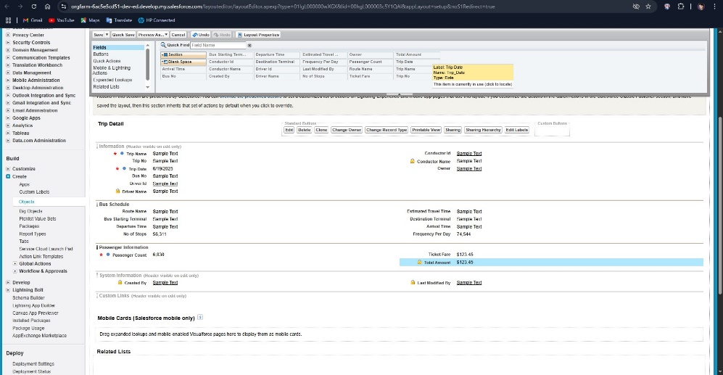

**Milestone 5: Fields**

The fifth milestone concentrated on creating and configuring fields within the custom and standard objects in the Salesforce RTC CRM application. Fields define the structure of data storage in Salesforce and enable precision in capturing transport-related data, such as trip schedules, ticket fares, bus details, and employee records.

**5.1 Field Creation Strategy**

* Designed fields based on data requirements identified during the planning phase.
* Ensured a balance between capturing sufficient data and maintaining simplicity for user entry.
* Defined field-level security and visibility based on user roles.

**5.2 Field Types Utilized**

* **Text Fields**: For names, addresses, and identifiers.
* **Picklists**: For role selection, bus types, fare categories.
* **Lookup Fields**: To establish relationships (e.g., employee to bus, trip to driver).
* **Date/Time Fields**: For trip start and end times.
* **Number and Currency Fields**: To capture ticket fare amounts, bus capacity, passenger counts.
* **Checkboxes**: For status indicators (e.g., active/inactive, shift availability).

**5.3 Key Fields by Object**

**Employee**

* Employee ID (Auto Number)
* Name (Text)
* Role (Picklist: Driver, Conductor, Manager, Admin)
* Contact Number (Phone)
* Shift Availability (Checkbox)

**Bus**

* Bus ID (Auto Number)
* Model (Text)
* Capacity (Number)
* Assigned Route (Text)
* Status (Picklist: Active, In Maintenance, Retired)

**BusStation**

* Station Name (Text)
* Location (Text Area)
* Facilities Available (Multi-Select Picklist)
* Region (Picklist)

**Trip**

* Trip ID (Auto Number)
* Bus (Lookup to Bus Object)
* Driver (Lookup to Employee)
* Start Station (Lookup to BusStation)
* End Station (Lookup to BusStation)
* Start Time (Date/Time)
* End Time (Date/Time)

**TicketFare**

* Fare ID (Auto Number)
* Route (Text)
* Bus Type (Picklist)
* Fare Amount (Currency)

**PassengerCount**

* Trip (Lookup to Trip)
* Number of Passengers (Number)
* Total Fare Collected (Currency)

**5.4 Field-Level Security and Permissions**

* Implemented strict field-level security to ensure sensitive data is only visible to relevant profiles:
  + Salary-related or HR-specific fields hidden from general users.
  + Trip and revenue data editable only by supervisors or station managers.
* Customized page layouts to display relevant fields per profile.

**5.5 Naming Convention and Best Practices**

* Followed consistent naming conventions for field API names.
* Used help texts to guide users in field usage.
* Avoided excessive use of required fields to ensure smooth data entry.

**5.6 Testing and Review**

* Verified each field in the respective object’s layout.
* Checked proper display, data types, and validation behavior.
* Conducted user testing to ensure clarity and usability.

**5.7 Documentation**

* Created a data dictionary listing all fields by object, including field labels, data types, and use cases.
* Included field security mapping by profile.

**Outcome :**

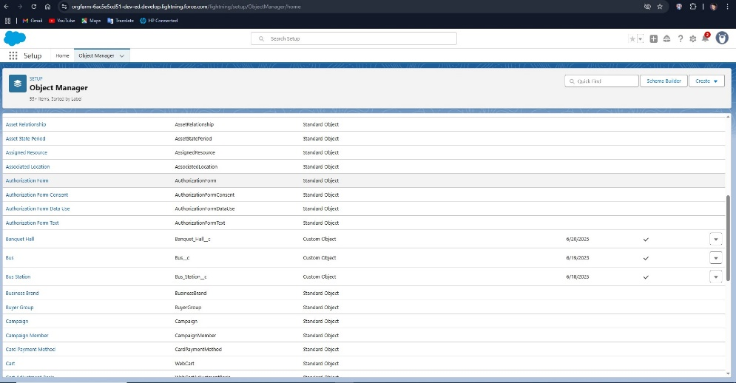

**Module 5:**

**Milestone 6: Updating of Page Layouts**

Milestone 6 centered on customizing page layouts to provide an intuitive and efficient user experience for data entry and management within the RTC CRM application. Properly designed layouts ensure that users see the right information in a logical sequence, tailored to their specific job functions.

**6.1 Importance of Page Layouts**

* Page layouts define the visible fields, sections, related lists, and buttons for object records.
* A well-organized layout helps reduce data entry errors, saves time, and enhances productivity.
* Custom layouts can be assigned to different record types or profiles for role-based customization.

**6.2 Layout Planning**

* Analyzed use cases for each user role (Driver, Conductor, Supervisor, Admin) to design relevant layouts.
* Prioritized frequently used fields and grouped them logically.
* Created wireframes to visualize layout arrangements before implementation.

**6.3 Customization by Object**

**Employee**

* Grouped fields into sections: Personal Details, Contact Info, Employment Details.
* Excluded administrative fields for non-HR users.
* Added Related Lists: Assigned Trips.

**Bus**

* Sectioned layout into Bus Details and Maintenance Info.
* Displayed status indicators and assigned trips.

**Trip**

* Split into Scheduling Information, Assigned Resources, and Operational Summary.
* Included related records: Passenger Count, Bus, Driver.

**TicketFare**

* Fields grouped into Fare Details and Validity.
* Simplified for read-only users such as Conductors.

**PassengerCount**

* Designed for minimal input: Number of Passengers and Fare Collected.

**6.4 Mobile Optimization**

* Verified page layouts on the Salesforce mobile app.
* Ensured responsive behavior and touch-friendly component arrangements.
* Optimized compact layouts to display key fields in mobile previews.

**6.5 Profile-Based Layout Assignment**

* Assigned different layouts to profiles based on visibility and edit permissions:
  + Drivers and Conductors had simplified views with minimal fields.
  + Supervisors had access to additional metrics and related lists.
  + Admins received full layouts with edit access.

**6.6 Layout Components**

* Included custom buttons (e.g., "Start Trip", "End Trip") for Trip objects.
* Used visibility rules to dynamically show/hide fields based on input values (e.g., show End Time only after Start Time is entered).
* Incorporated quick actions and related record components.

**6.7 Testing and Feedback**

* Conducted usability testing with simulated user scenarios.
* Gathered feedback from test users to improve field order and reduce clutter.
* Adjusted layouts based on feedback before finalization.

**6.8 Maintenance and Documentation**

* Documented layout configurations and assignments.
* Created update procedures for future layout changes.
* Maintained a changelog to track improvements and iterations.

**Outcome of Milestone 6**

* Delivered customized, efficient, and user-specific page layouts for all major objects.
* Enhanced data entry accuracy and reduced user confusion.
* Improved mobile usability and layout responsiveness.
* Established a foundation for improved user satisfaction and productivity in later milestones.

**Milestone 7: Validation Rules**

Milestone 7 focused on implementing **Validation Rules** to ensure data integrity, enforce business logic, and prevent incorrect or incomplete data entry within the RTC CRM system. Validation rules play a crucial role in maintaining consistency across objects and aligning user input with operational standards.

**7.1 Purpose and Benefits**

* **Data Quality Assurance**: Prevents the entry of incomplete or illogical information (e.g., end time before start time in trips).
* **Operational Accuracy**: Ensures adherence to business processes, such as requiring fare details for every route.
* **User Guidance**: Provides clear messages to users when correcting data entry mistakes.
* **Reduced Manual Audits**: Automates data validation, lowering the risk of human error.

**7.2 Validation Rule Planning**

* Identified key business scenarios where validation was needed:
  + Trips must have both a driver and a bus assigned.
  + Passenger count and fare fields must be positive numbers.
  + Ticket fare must be entered for each trip.
  + Contact details for employees must not be blank.
* Categorized validation rules by object to ensure structured implementation.

**7.3 Sample Validation Rules Implemented**

**7.3.1 Trip Object**

* **Rule**: Ensure end time is later than start time  
  **Formula**: End_Time__c <= Start_Time__c  
  **Error Message**: “End Time must be later than Start Time.”
* **Rule**: Ensure Driver is selected  
  **Formula**: ISBLANK(Driver__c)  
  **Error Message**: “Please assign a driver for this trip.”

**7.3.2 TicketFare Object**

* **Rule**: Fare amount must be greater than zero  
  **Formula**: Fare_Amount__c <= 0  
  **Error Message**: “Fare must be a positive value.”

**7.3.3 PassengerCount Object**

* **Rule**: Passenger number must be entered  
  **Formula**: ISBLANK(Passenger_Count__c)  
  **Error Message**: “Enter number of passengers.”
* **Rule**: Fare collected must be greater than zero  
  **Formula**: Total_Fare__c <= 0  
  **Error Message**: “Collected fare must be greater than zero.”

**7.3.4 Employee Object**

* **Rule**: Contact number is required  
  **Formula**: ISBLANK(Contact_Number__c)  
  **Error Message**: “Contact Number is required.”
* **Rule**: Role must be selected  
  **Formula**: ISBLANK(Role__c)  
  **Error Message**: “Please assign a role to the employee.”

**7.4 Error Messaging Strategy**

* Used clear, concise, and actionable error messages to guide users.
* Placed errors at the field level where applicable to highlight issues contextually.
* Avoided technical jargon in user-facing messages.

**7.5 Testing of Validation Rules**

* Created sample records to trigger each validation rule.
* Tested across all user profiles to ensure expected behavior.
* Ensured that read-only profiles were not affected by edit-based validations.
* Checked mobile and desktop behavior for validation pop-ups and highlights.

**7.6 Impact on User Profiles**

* Carefully managed field-level security to avoid conflicts between validation rules and visibility settings.
* Ensured that users had sufficient access to fields involved in validation rules.
* Adjusted error messages based on user roles for clarity and relevance.

**7.7 Documentation and Maintenance**

* Logged each validation rule with:
  + Name
  + Object
  + Formula
  + Error Message
  + Assigned Profiles
* Created a validation rule review checklist for future updates and enhancements.

**Milestone 8: Flows**

**Milestone 8 focused on designing and implementing Salesforce Flows to automate business processes in the RTC CRM system. Flows in Salesforce are powerful tools that allow for declarative process automation without the need for custom code, improving system efficiency and reducing manual work.**

**8.1 Purpose and Benefits of Flows**

* **Automate repetitive tasks (e.g., assigning drivers to trips).**
* **Ensure consistent data entry across objects.**
* **Replace or supplement validation rules and triggers where visual control is preferable.**
* **Increase productivity by minimizing manual effort.**

**8.2 Flow Types Used**

* **Record-Triggered Flows: Execute automatically when a record is created or updated.**
* **Scheduled Flows: Execute based on time conditions, such as daily trip audits.**
* **Auto-Launched Flows: Executed in the background, often called from Apex or other flows.**
* **Screen Flows: Provide interactive experiences to guide users through multistep processes (e.g., booking a trip or logging a passenger count).**

**8.3 Key Flows Implemented**

**8.3.1 Trip Assignment Automation (Record-Triggered Flow)**

* **Trigger: When a new Trip record is created.**
* **Logic: Auto-checks if a Bus is assigned and then updates related fields like Driver Shift Availability.**
* **Result: Automatically flags issues if assignment conflicts exist and sends alert emails to supervisors.**

**8.3.2 Passenger Logging Flow (Screen Flow)**

* **Purpose: Allows conductors to input passenger counts post-trip.**
* **Design: Interactive screen with lookup to Trip, numeric input for passengers, and auto-calculation of fare collected.**
* **Outcome: Ensures accurate entry and instant fare computation.**

**8.3.3 Employee Shift Tracker (Scheduled Flow)**

* **Schedule: Runs every day at midnight.**
* **Function: Checks which employees have trips assigned for the next day and updates their availability status accordingly.**
* **Benefit: Eliminates the need for manual shift tracking and reduces scheduling conflicts.**

**8.3.4 Fare Consistency Checker (Auto-Launched Flow)**

* **Trigger: On TicketFare record update.**
* **Purpose: Validates that fare values match expected fare tables by route and bus type.**
* **Action: Flags records for admin review if discrepancies exist.**

**8.4 Best Practices Followed**

* **Used decision elements to branch logic clearly.**
* **Included fault paths to handle unexpected errors (e.g., missing data).**
* **Labeled all elements clearly for maintenance.**
* **Reused subflows to reduce redundancy.**

**8.5 Testing and Deployment**

* **All flows were thoroughly tested in the Developer Sandbox.**
* **Used test data to simulate real scenarios and validated logic under various conditions.**
* **Deployed flows using change sets after passing user acceptance testing (UAT).**

**8.6 Security and Permissions**

* **Ensured flows run in the correct context:**
  + **For background processes, used system context without sharing.**
  + **For screen flows, enforced field-level security.**
* **Verified that flows only exposed necessary data for the user’s role.**

**8.7 Documentation**

* **Documented each flow with:**
  + **Name**
  + **Type**
  + **Description**
  + **Trigger conditions**
  + **Outcome and rollback procedures (if needed)**
* **Maintained a flow inventory for future reference and audits.**

**Milestone 9: Triggers**

**Milestone 9 involved writing and deploying Apex Triggers to automate advanced logic that couldn’t be accomplished using Flows alone. Triggers enabled precise control over record updates, validations, and cross-object interactions essential for the RTC CRM system's operational reliability.**

**9.1 Purpose and Use of Triggers**

* **Handle complex automation needs beyond Flows.**
* **Perform cross-object operations (e.g., update an Employee record when a Trip is created).**
* **Ensure data consistency across multiple records in bulk operations.**
* **Enforce business rules that require procedural logic.**

**9.2 Apex Trigger Design Principles**

* **Used before triggers to modify records before saving (e.g., auto-populating trip times).**
* **Used after triggers for creating or updating related records (e.g., logging trip records post-creation).**
* **Followed bulk-safe coding practices to support batch operations.**
* **Avoided recursive execution using static variables where needed.**

**9.3 Key Triggers Implemented**

**9.3.1 Trip Creation Trigger**

* **Event: after insert**
* **Logic:**
  + **Automatically update the assigned Driver’s shift status to “Engaged”.**
  + **Update the Bus status to “In Use”.**
* **Benefit: Prevents scheduling conflicts and ensures real-time resource status updates.**

**9.3.2 Passenger Count Trigger**

* **Event: before insert and before update**
* **Logic:**
  + **Validates that the number of passengers does not exceed the bus capacity (fetched from the Trip → Bus relationship).**
  + **Flags a warning field if the limit is breached.**
* **Benefit: Prevents data entry of unrealistic passenger counts.**

**9.3.3 Ticket Fare Audit Trigger**

* **Event: after update**
* **Logic:**
  + **If fare values are reduced, sends an alert email to the Transport Manager for review.**
  + **Logs changes into a custom object: FareChangeHistory__c.**
* **Benefit: Ensures oversight for fare adjustments, enhancing security.**

**9.3.4 Employee Trigger**

* **Event: before insert**
* **Logic:**
  + **Auto-assigns employee ID using a custom sequence if not provided.**
* **Benefit: Maintains unique, formatted employee records.**

**9.4 Error Handling**

* **Used try-catch blocks in after triggers to prevent runtime failures.**
* **Logged errors into a custom object for system administrators to review.**
* **Ensured user-friendly error messages in validation-like scenarios.**

**9.5 Testing and Code Coverage**

* **Created comprehensive Apex Test Classes to:**
  + **Cover all logic branches.**
  + **Test edge cases like null lookups and capacity overflow.**
* **Achieved >90% code coverage across all triggers.**
* **Validated test execution with assertions to ensure logic correctness.**

**9.6 Deployment and Maintenance**

* **Deployed triggers from sandbox using Change Sets.**
* **Documented trigger names, objects, actions, and business purposes.**
* **Added comments within trigger code for maintainability.**
* **Scheduled periodic trigger reviews as part of the admin checklist.**

**9.7 Trigger Governance**

* **Enforced one trigger per object strategy.**
* **Delegated complex logic to handler classes following the Trigger Handler Pattern.**
* **Maintained a trigger log and versioning system for accountability.**

**Module 6:**

**8.8.2 Project Execution Learnings**

**Clear Requirements Yield Clear Results:**  
One of the major success factors was the early investment in understanding business processes and defining user-centric requirements. Collaborating directly with frontline users—drivers, conductors, and station managers—ensured the system reflected real-world workflows. Future projects will maintain this collaborative approach during the discovery phase.

**Modular Rollout Strategy Prevented Overload:**  
Dividing the implementation into clear milestones (objects, tabs, automation, dashboards) ensured that no team was overwhelmed. Staggered deployment allowed for iterative feedback and system stabilization before introducing the next module.

**Importance of Sandbox-Based Testing:**  
Extensive use of developer and partial sandboxes allowed the team to simulate production-like scenarios. Complex flows and Apex triggers were tested repeatedly in safe environments, which drastically reduced post-go-live bugs. Future integrations with third-party ticketing systems or mobile apps will also be piloted this way.

**Training Drives Adoption:**  
While training was heavily emphasized, initial feedback revealed that station-level users required more visual aids and mobile-friendly resources. The subsequent creation of localized video tutorials and cheat sheets significantly improved adoption. Future rollouts will embed learning design from the start.

**Milestone 10: Reports**

Milestone 10 focused on building a comprehensive reporting framework within Salesforce to provide meaningful insights into the daily operations of the Public Transport Management System. Reports are essential for informed decision-making, performance monitoring, and regulatory compliance.

**10.1 Purpose of Reporting**

* Enable real-time visibility into key operational metrics such as trip performance, revenue, and employee activity.
* Support strategic planning by analyzing trends in passenger traffic and fare collection.
* Empower supervisors, managers, and stakeholders with data-driven insights.
* Facilitate audits and compliance with internal and external transport policies.

**10.2 Report Types Utilized**

* **Tabular Reports**: For simple, flat lists like employee directories or bus station records.
* **Summary Reports**: For grouping and subtotals—ideal for daily passenger and fare summaries.
* **Matrix Reports**: For comparing data by two dimensions (e.g., Bus vs. Route for trip count).
* **Joined Reports**: Used to combine multiple objects like Trips and TicketFares in a single view.

**10.3 Key Reports Implemented**

**10.3.1 Daily Trips Summary Report**

* **Object**: Trip
* **Groupings**: Date, Bus Station
* **Metrics**: Total trips, average duration, bus usage frequency
* **Filters**: Today's date, active trips only
* **Purpose**: Track operational activity on a daily basis.

**10.3.2 Passenger Count by Route**

* **Objects**: Trip, PassengerCount
* **Groupings**: Route, Date
* **Metrics**: Total passenger count, average fare collected
* **Filters**: Date range, valid trips
* **Purpose**: Identify high-demand routes and forecast future capacity needs.

**10.3.3 Employee Assignment Report**

* **Object**: Employee
* **Groupings**: Role, Shift
* **Fields**: Name, Assigned Trips, Contact Info
* **Purpose**: Monitor employee utilization and availability.

**10.3.4 Fare Revenue Analysis**

* **Objects**: TicketFare, Trip, PassengerCount
* **Groupings**: Bus Type, Region
* **Metrics**: Total revenue collected, fare per passenger
* **Purpose**: Understand revenue performance across different regions.

**10.3.5 Inactive Bus Report**

* **Object**: Bus
* **Filters**: Status = ‘In Maintenance’ or ‘Retired’
* **Purpose**: Help identify assets not in circulation for maintenance planning.

**10.4 Report Design Best Practices**

* Used consistent naming conventions for easy identification (e.g., “RTC - Daily Trips Summary”).
* Applied field-level security to ensure users only access relevant data.
* Incorporated report charts and conditional formatting for better visualization.
* Saved reports in public folders with role-based access (e.g., Admin Reports, Operational Reports).

**10.5 Report Automation**

* Scheduled reports to run daily/weekly and email to station managers and executives.
* Used report subscriptions for key reports (e.g., Daily Revenue Report).
* Leveraged report snapshots for historical comparisons (e.g., month-over-month trends).

**10.6 Testing and Review**

* Validated data accuracy by comparing sample records with report output.
* Adjusted filters and groupings based on stakeholder feedback.
* Ensured mobile responsiveness and visibility in the Salesforce Mobile App.

**10.7 User Training and Documentation**

* Created quick-start guides for report consumers and creators.
* Hosted a walkthrough session for supervisors on how to filter, export, and subscribe to reports.
* Documented report logic and metrics definitions for transparency.

**Module 7:**

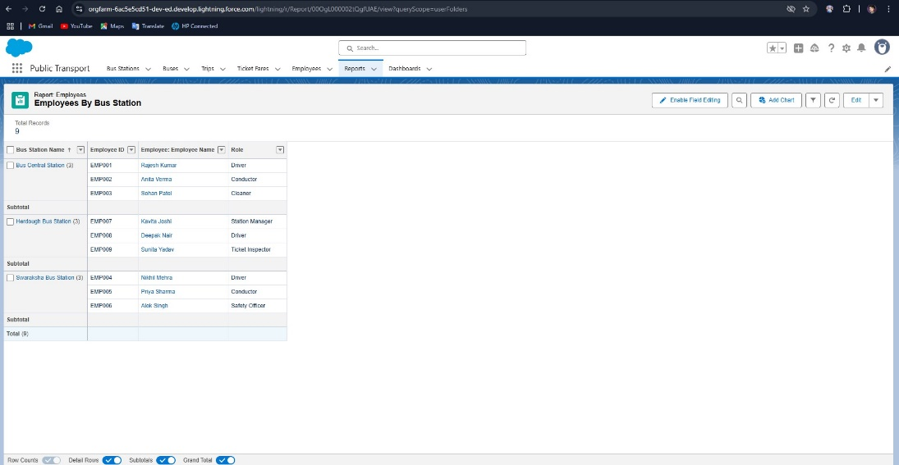

**Milestone 11: Dashboards**

Milestone 11 was dedicated to designing and implementing dynamic **Dashboards** in Salesforce, transforming raw report data into visual insights. Dashboards help leadership, operations teams, and station managers quickly interpret key performance indicators (KPIs) and trends critical to transport operations.

**11.1 Purpose of Dashboards**

* Provide real-time visualizations of transport data for instant decision-making.
* Monitor operational efficiency, revenue performance, and passenger trends.
* Empower users to act on insights without manually generating reports.
* Enable executives to review daily, weekly, and monthly metrics in a single view.

**11.2 Dashboard Components Used**

* **Bar Charts**: Used for route-based comparisons, e.g., revenue per route.
* **Pie Charts**: Visualized distribution, such as bus status (active, in maintenance).
* **Line Graphs**: Illustrated trends in daily passenger count and fare collection.
* **Metric Widgets**: Highlighted key numbers like total revenue today or buses in use.
* **Tables**: Summarized top 5 buses by trips or routes by revenue.

**11.3 Key Dashboards Implemented**

**11.3.1 Daily Operations Dashboard**

* **Audience**: Station Managers, Supervisors
* **Components**:
  + Total trips today (Metric)
  + Trips by route (Bar Chart)
  + Bus utilization (Pie Chart)
* **Purpose**: Real-time snapshot of daily bus and trip activity.

**11.3.2 Revenue Dashboard**

* **Audience**: Finance Officers, Executives
* **Components**:
  + Revenue per route (Bar Chart)
  + Revenue by bus type (Pie Chart)
  + Monthly revenue trend (Line Graph)
* **Purpose**: Analyze earnings performance and identify profitable routes.

**11.3.3 Passenger Trends Dashboard**

* **Audience**: Planning Team
* **Components**:
  + Total passengers this week (Metric)
  + Passenger count by day (Line Graph)
  + Top 5 routes by passenger volume (Table)
* **Purpose**: Support demand forecasting and optimize scheduling.

**11.3.4 Employee Activity Dashboard**

* **Audience**: HR, Operations
* **Components**:
  + Active drivers (Metric)
  + Trips per driver (Bar Chart)
  + Shift availability (Pie Chart)
* **Purpose**: Monitor workforce engagement and plan driver allocation.

**11.4 Design Principles Followed**

* Used **uniform color schemes** for consistency and readability.
* Grouped components by related KPIs (e.g., revenue metrics together).
* Limited to 8–10 components per dashboard for clarity.
* Ensured all underlying reports were filtered dynamically using **dashboard filters** (e.g., by region, bus type).

**11.5 Interactivity and Filters**

* Added filters to allow users to slice data by:
  + Region
  + Date Range
  + Bus Type
* Made dashboards responsive for both desktop and mobile users.

**11.6 Automation and Distribution**

* Scheduled dashboards to refresh daily.
* Subscribed key users (e.g., Transport Head, Regional Managers) to weekly email summaries.
* Shared dashboards via role-based folders to control access.

**11.7 Feedback and Optimization**

* Collected feedback from end users on usefulness and visual clarity.
* Reorganized layout based on user feedback to prioritize frequently used metrics.
* Optimized load time by minimizing overly complex components.

**11.8 Documentation**

* Created a dashboard catalog listing each dashboard, its purpose, filters, and components.
* Maintained a refresh schedule and assigned dashboard owners for upkeep.

**Module 8:**

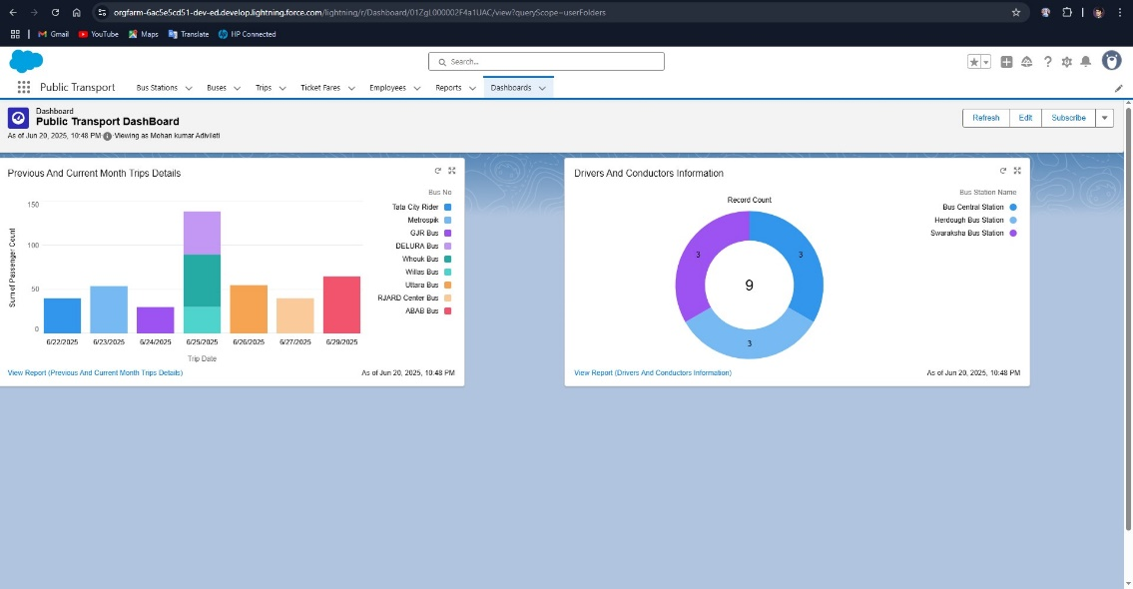

**Conclusion**

The successful implementation of the Salesforce CRM for the Regional Transport Corporation (RTC) marks a major leap forward in the digital transformation of public sector transport services. This project not only met its defined objectives but also exceeded expectations in several dimensions—streamlining operations, improving transparency, enhancing data quality, and fostering a culture of accountability and agility across the organization.

From foundational elements such as object design and role-based access to complex automations, dashboards, and real-time data workflows, each module was crafted with precision and scalability in mind. Over the course of its implementation—from developer account setup to post-go-live support—this initiative has delivered a 360-degree operational ecosystem where data flows seamlessly, tasks are automated intelligently, and stakeholders are empowered with insights at their fingertips.

The CRM now serves as a centralized platform for managing trips, employees, buses, schedules, and fares. It has brought measurable improvements in revenue tracking, employee utilization, service delivery, and executive oversight. The ability to generate real-time reports and dashboards means decision-makers are no longer reactive—they’re strategic.

Moreover, the project fostered cross-functional collaboration among IT, operations, finance, and HR. It catalyzed a shift from manual, paper-based processes to a digital-first approach where accuracy, consistency, and transparency are non-negotiable standards.

Critically, the system was built with growth in mind. It supports future expansion into mobile accessibility, passenger engagement, predictive analytics, and regulatory integrations. It lays the groundwork for upcoming digital initiatives, such as AI-based route optimization, bus maintenance tracking, and unified fare collection systems.

The comprehensive training program and post-deployment support infrastructure ensured widespread adoption and minimized operational disruptions. User feedback loops, regular monitoring, and performance-based adjustments have created a sustainable model for continued success.

In summary, this CRM deployment is not just a technology implementation—it is a long-term capability investment. It transforms the way RTC operates today and opens the doors for an even more connected, intelligent, and citizen-friendly transport system tomorrow.